

AMERICAN INTERNATIONAL UNIVERSITY–BANGLADESH (AIUB)
Dept. of Computer Science
Faculty of Science and Technology

CSC 01409: PROGRAMMING IN PYTHON
Spring: 2025-2026
Section: [C]
Group No: 612

Project Report On
Project Name [Cash Flow]

Supervised By
Name | ID
1. ALIF HASAN KHAN | 23-50186-1
2. MD YEAHYEA JAM | 23-50187-1
3. SADMAN SHAKIB | 23-50200-1
MD. Tanzeem Rahat
Submitted By:

1. Introduction
Cash Flow CLI is a command-line based financial management system designed to help users track their income and expenses efficiently. It provides a simple and user-friendly interface for managing personal financial records directly from the terminal.
In today’s fast-paced world, managing finances is essential. This application offers a lightweight and offline solution that allows users to maintain financial data securely without relying on external platforms.

2. Key Features
- Add Income: Users can add income entries with category, amount, and date
- Add Expense: Users can record expenses with necessary details
- View Transactions: Displays all transactions in a structured table
- Search Transactions: Allows searching by category or date
- Update Transactions: Modify existing transaction details
- Delete Transactions: Remove unwanted entries using transaction ID
- Summary Report: Shows total income, total expenses, and net balance
- Input Validation: Ensures correct data entry

3. System Architecture
The system follows a modular architecture for better maintainability and scalability.
Module | Responsibility
main.py | The application entry point and main execution loop.
CLI_UI.py/ Features.py | Handles user interaction and terminal formatting.
service.py | Contains core business logic and operation orchestration.
Finance_Service.py | Manages key generation and AES encryption/decryption.
storage.py | Handles JSON persistence and file I/O operations.
utils.py | Helper functions for validation and strength checks.

4. Technologies Used
- Python 3.x – Core programming language
- Colorama – For colored terminal output
- Tabulate – For displaying data in table format
- JSON – For data storage

5. How to Run the Project
To get the project running on a local machine, follow these steps in a terminal or command prompt:
- Clone the repository to your local directory.
- git clone https://github.com/MIHMahmudEli/PasswordVault.git
- cd PasswordVault
- Set up a virtual environment (Optional but Recommended):
- Windows:
- python -m venv .venv
- .venv\Scripts\activate
- macOS/Linux::
- python3 -m venv .venv
- source .venv/bin/activate
- Install dependencies:
- pip install -r requirements.txt
- Run the application:
- python main.py

6. Conclusion
The Cash Flow CLI project successfully demonstrates the use of Python in developing a real-world application. It highlights key programming concepts such as Object-Oriented Programming, file handling, modular design, and validation techniques. This project provides a solid foundation for building more advanced financial systems in the future.

7. Screenshots
7.1 Add a new income
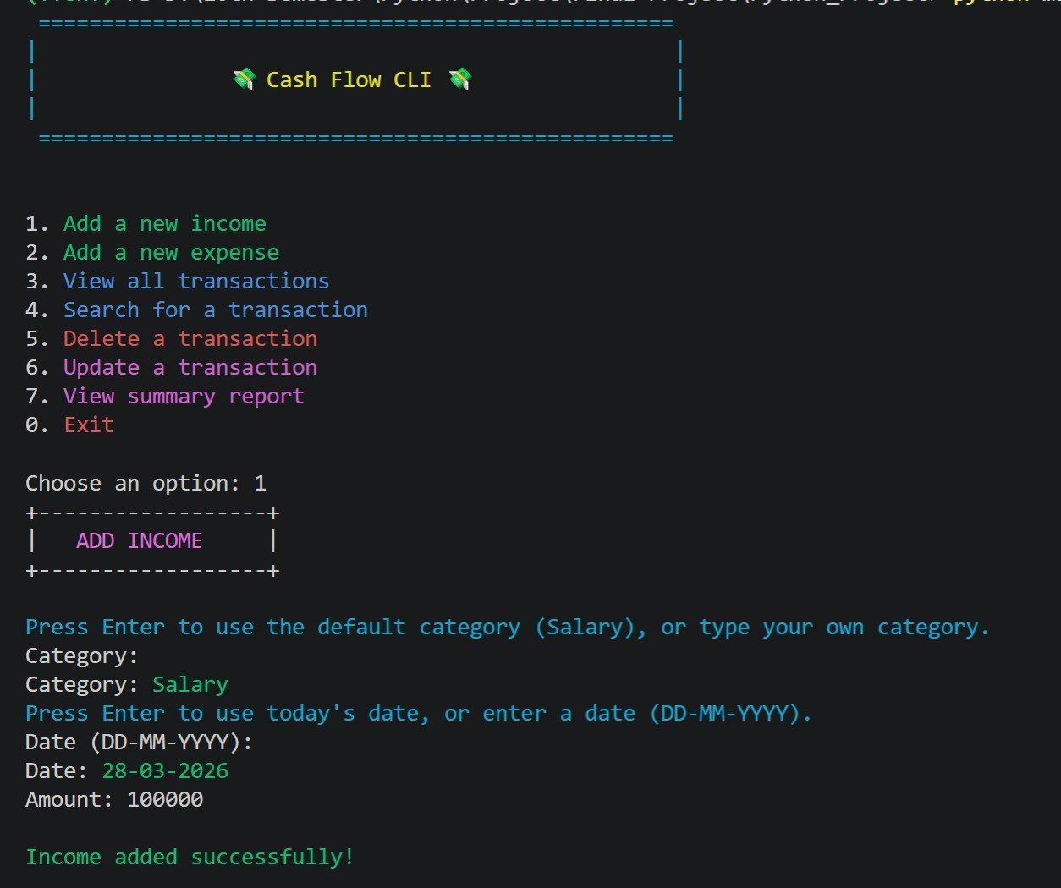

7.2 Add a new expense
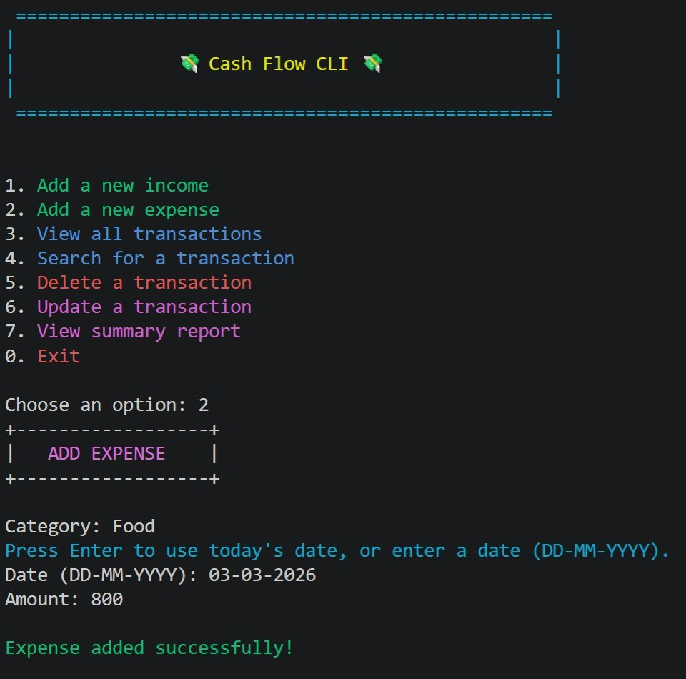

7.3 View all transactions
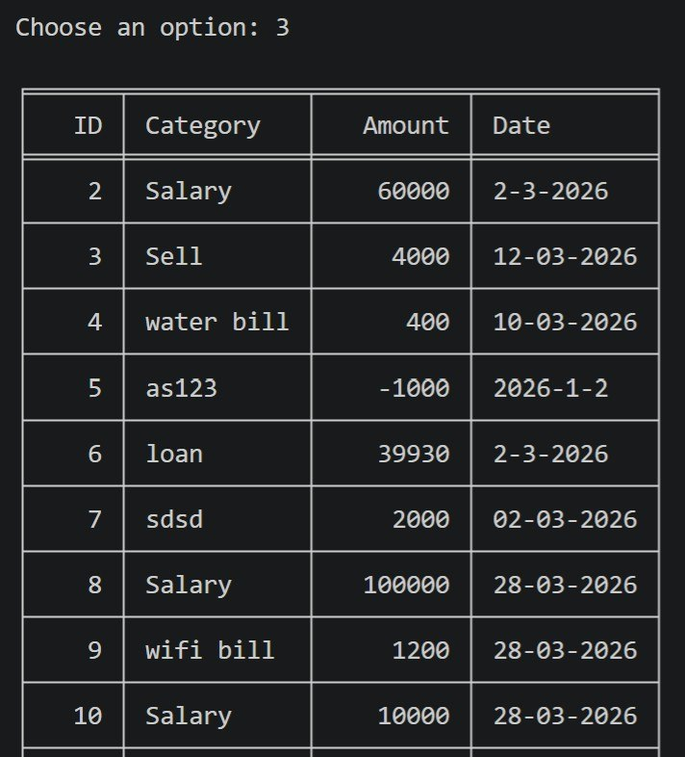

7. 4 Search for a transaction
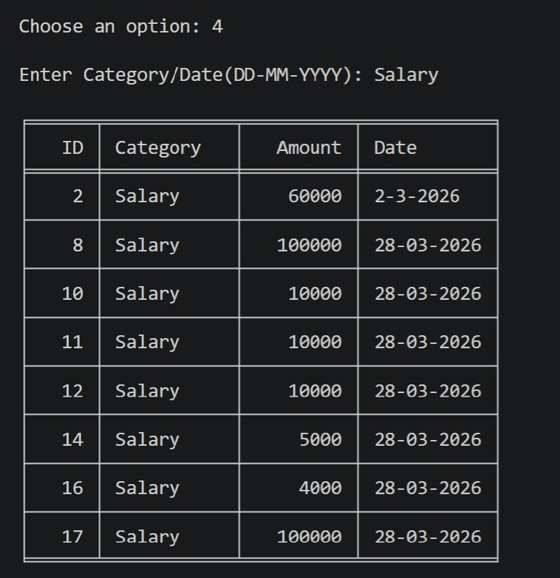

7.5 Delete a transaction
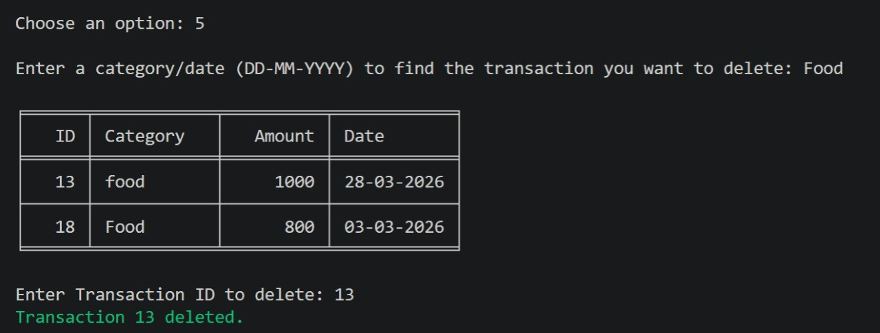

7. 6. Update a transaction
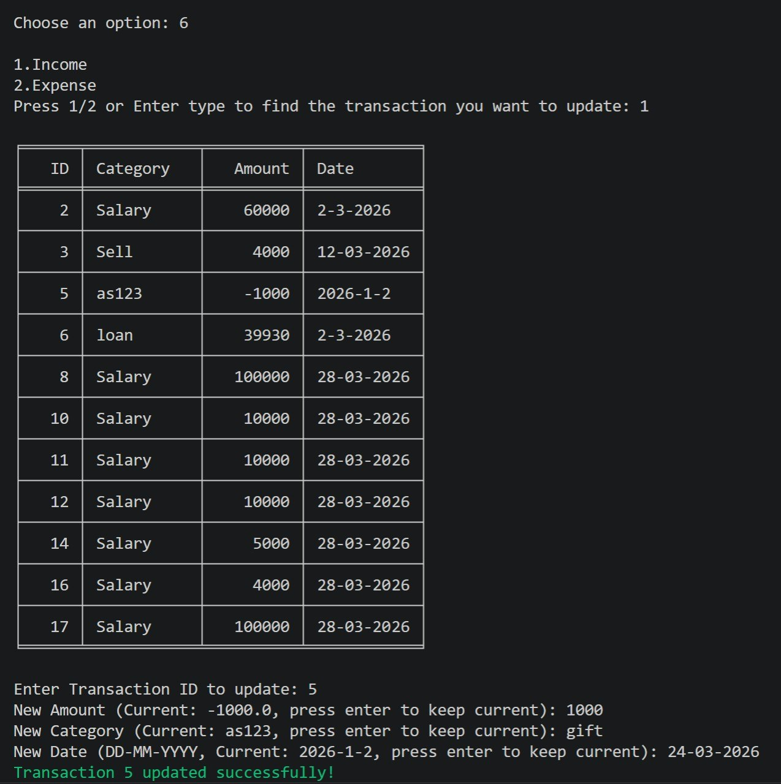

7. 7 View summary report
